**Dynamic background and active system rectangles**

In this version we have dynamic background so can be changed very easy without return to development department, we also have dynamic system interact with mouse move and click to open the required system and not just image as before

When u move the mouse on the sub system name it will change it’s color as shown

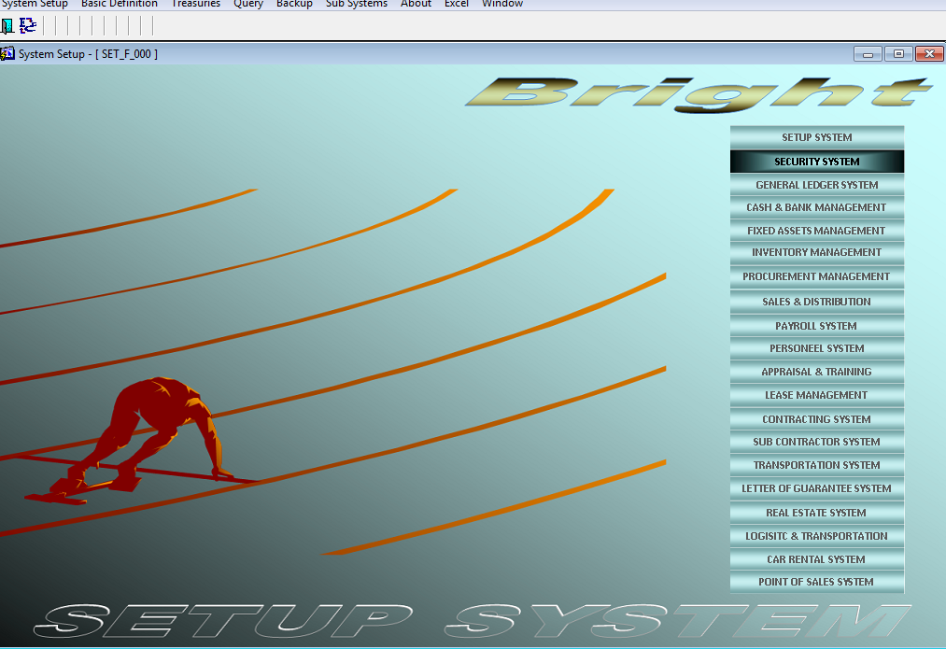

Also when u press it it will interact with you to open this system and not just image as before

Also all this backgrounds can be changed by replacing the images in the following folder

BRIGHT_PATH\IMAGE

**Easier navigation between forms that is already open**

Before when you open a form that is already open the system don’t do anything and you have to chose it from windows menu, in this version

If you open a form that is already open the system will navigate to this form and make it active for you which make it easier to navigate between open forms.

**Easier navigation between systems**

Also before only navigation to other system from setup system but in this version navigation to other systems can be from any system which is much easier

Also the interactive rectangle for sub systems changed dynamically based on the modules the client bought.

In this version our client can change the default printing design for all the following documents:

* Sales Invoice
* Purchase Order
* Sales Return
* Purchase Return
* Service Invoice
* Service Return
* Purchase Invoice
* Missing Item Doc
* Return Item Doc
* Purchase Qutation
* Stock In
* Stock Out
* Journal Entry
* P. V. Cash
* R. V. Cash
* Sales Return Items
* Sales Quotation
* Pur. Service Invoice
* Pur. Return Invoice
* Progress Bill
* Items Price
* Supplier Bill
* Service Request
* Service Order
* Service Quotation
* Service Delivery
* Purchase Service Quotation
* Purchase Service Order
* Purchase Service Delivery
* Sales Order
* Purchase Service Location Request
* P. V. Bank Trans.
* P. V. Check
* R. V. Bank Trans.
* R. V. Check

Let us take sales invoice for example and the same mechanism applied for all other documents shown above

Sales invoice print changing example:

suppose the default design for sales invoice we have not satisfy the client, then the client can change it by chosing from different design we have for each document, to do this new screen created name “Change Document Printing” in setup system as shown

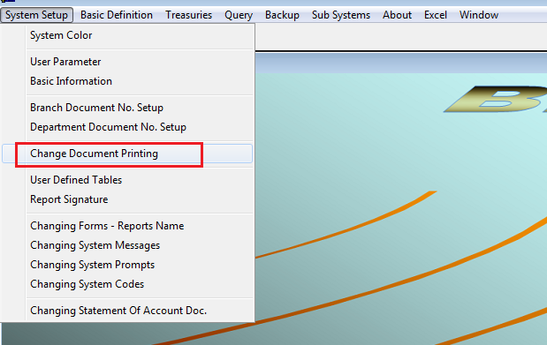

This screen show all the documents that the user now have the facility to change the way it print and it shown the number of template we have so far in bright, 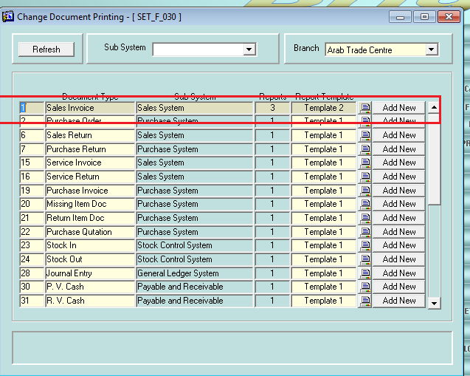

it also allow u to added any new design made for certain client for future use to all of our clients by pressing Add New button, the number of reports we can added as a template for each report is unlimited

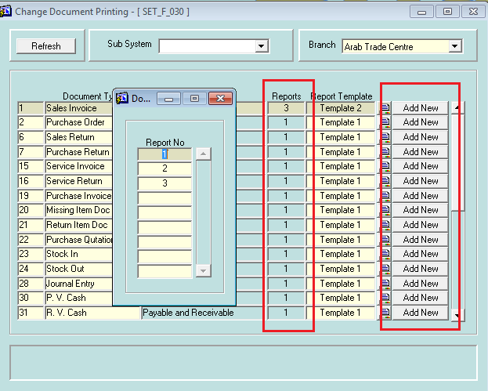

New change the report template by pressing F9 on report template field

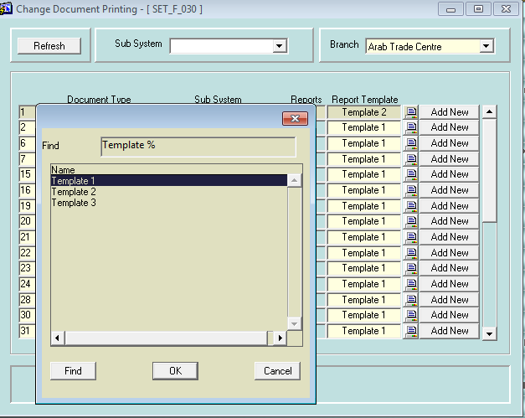

User can view the different design from this screen by pressing the print report

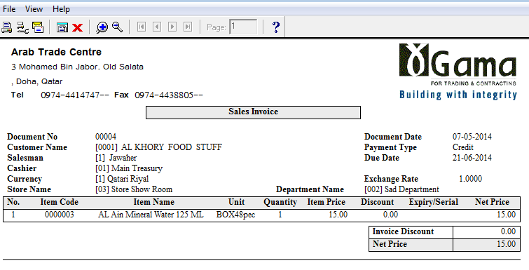

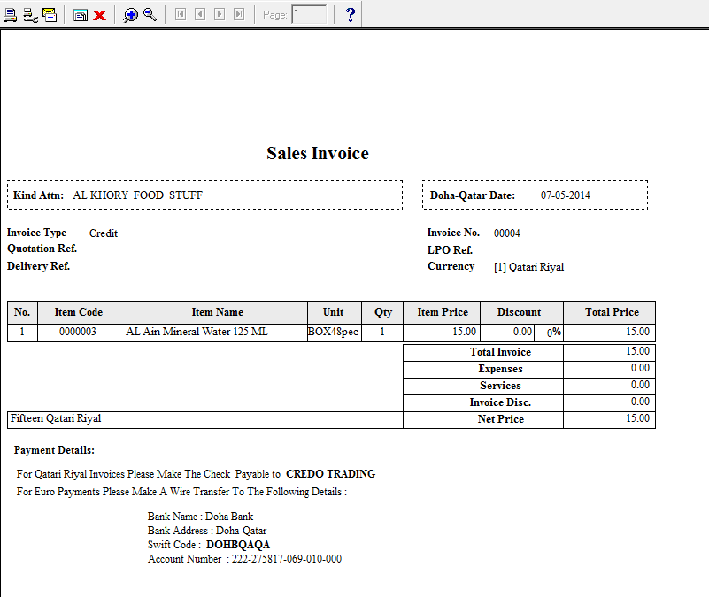

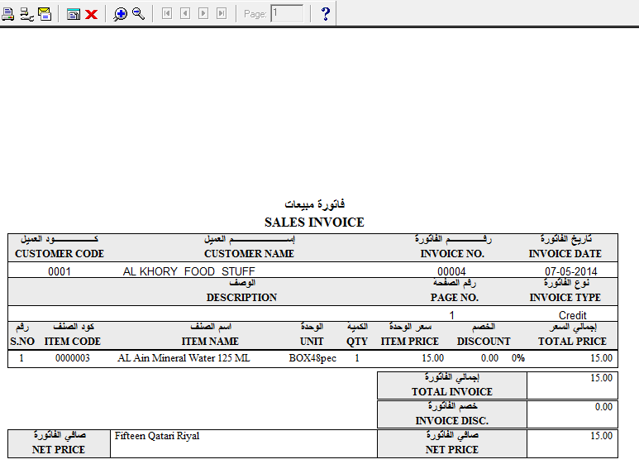

The design saved for each document type in this screen will reflect in the corresponding document so now if you go to sales invoice screen and print it there it will be printed by the new design u chose.

Dear All,

New feature: connect to time attendance machine directly and import the data from it automatically (i.e. without export the data to excel and import it into bright manually)

Also the connection will done automatically without human interfere and the update can done every 5 min to ensure that any change in time attendance machine will update in bright attendance tables at the same time.

So no need to let the user export the data to excel file from time attendance machine and then import this excel file manually into bright.

This is saving clients work and this can be instantly connected so any change in time attendance machine will automatically reflect in bright.

**Steps to develop connection between bright and time attendance database and transfer the data automatically:**

Steps:

1. Create odbc connection to the access database

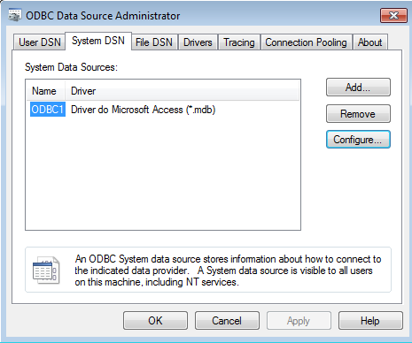

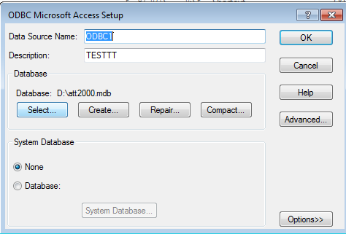

1. Edit the listener as shown

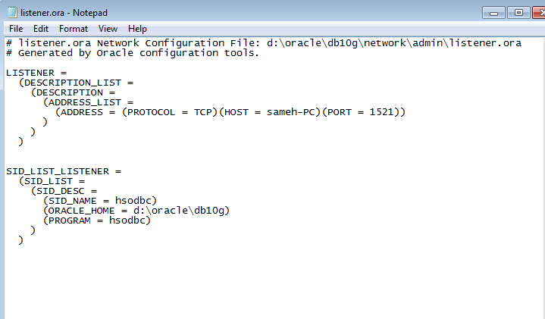

1. Stop and start the listener service or from the command line:   
   C:\> lsnrctl stop   
   C:\> lsnrctl start
2. Edit the ORACLE_HOME\hs\admin\inithsodbc.ora file and add your ODBC System DSN Name (ODBC1 in our case as defined in step 3).

HS_FDS_CONNECT_INFO = odbc1

HS_FDS_TRACE_LEVEL = off

1. Edit TNSNAMES.ORA

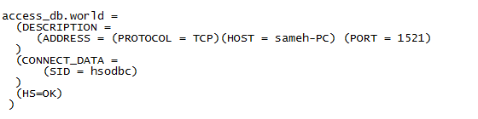

1. Create a database link

CREATE DATABASE LINK access_db USING 'access_db.world';

1. Create batch file to select the data from the access database and insert it into oracle database using the above link like the attached files att2000.bat and att2000.sql

In the attached batch file I transfer the data from CHECKINOUT table in access database att2000.mdb to bright database user BRIGHT_EGY using script .

Put this code in a batch file

D:\oracle\db10g\bin\SQLPLUS BRIGHT_EGY/BRIGHT_EGY@SAMEH @D:\ATT2000.SQL

Put this code in sql file in the same folder with name in the patch file above (D:\ATT2000.SQL in this example)

DELETE FROM CHECKINOUT;

INSERT INTO CHECKINOUT SELECT * FROM CHECKINOUT@access_db3;

COMMIT;

EXIT;

1. Schedule windows task to run this batch file every 5 min.

Done

Now when the data in finger print machine changed it will reflected in bright automatically.

Send sms to any mobile

Steps:

1. Run attached script sms.sql to your database.
2. Download sms server to monitor all sent message, let’s use for example Diafaan server, download it from this link <http://www.diafaan.com/>

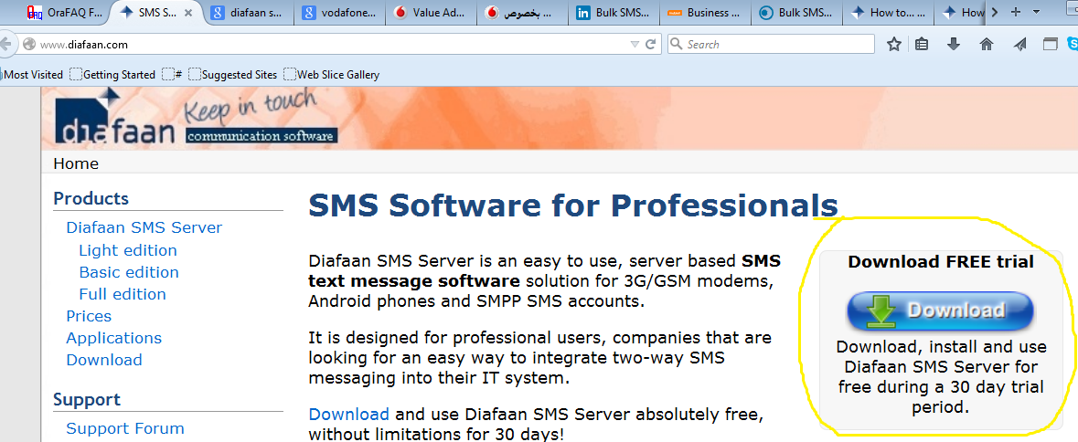

1. Add getway in the sms server to connect to our database by following this steps
   1. 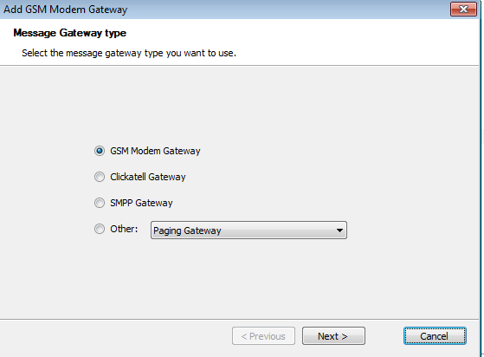
   2. Enter the data of GSM modem and if you don’t have GSM modem configure any android mobile to be GSM by going to android play store and download application called ‘Diafaan’ then enter the IP and Port it will give you

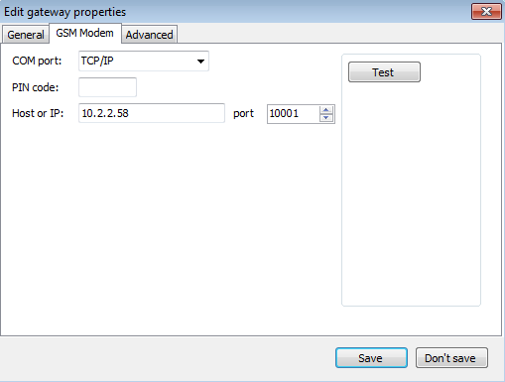

1. Create sql connector to our database by follow this steps:
   1. 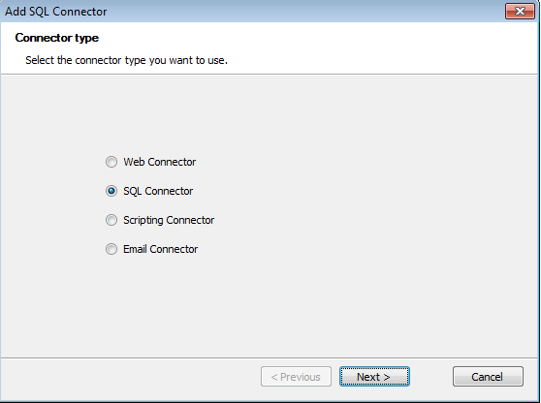

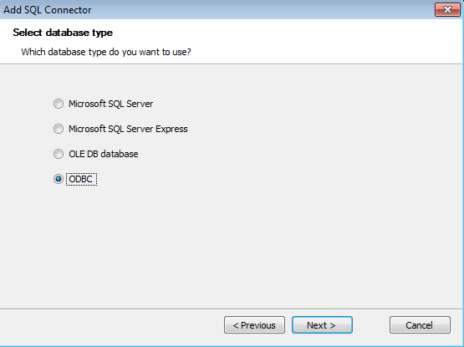

* 1. Add the ODBC connection as shown, put your server IP, user name and password, attached file ODBC.TXT
  2. 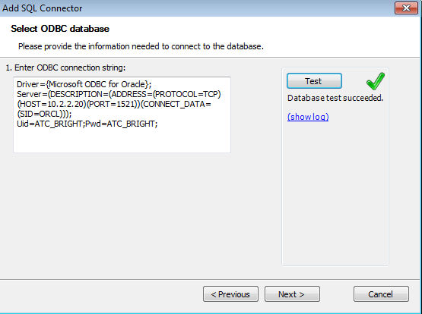
  3. Enter the following filed as marked by yellow

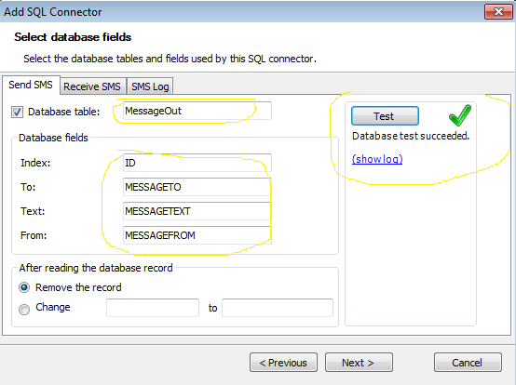

Now to send sms to any mobile anywhere just insert record in MessageOut table

For example

Insert into MessageOut (MESSAGETO,MESSAGETEXT)

Values (‘+201282091119’, ‘test message’);

OR use attached form

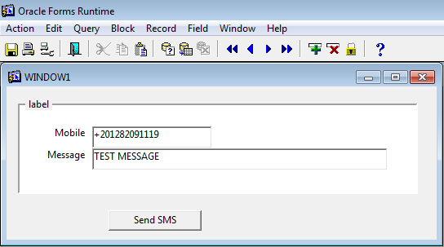

Done ☺

Now the message will go to the sms server and you can follow the status of it as shown:

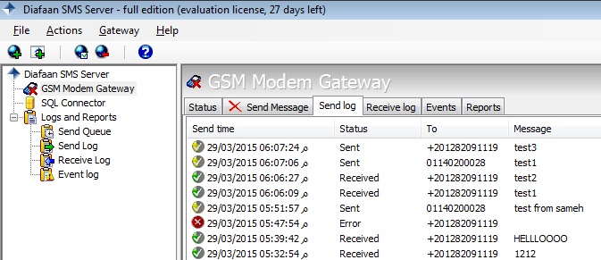

Advantage of this solution:

This solution guarantee:

* This solution work anywhere so it will work in Qatar, KSA and Egypt, also the steps is fixed and not changed by changing the country or the GSM service provider.
* Cheapest rate possible of sms ( I guarantee you there will be no price cheaper for sending sms) because it allow us to choose the GSM service provider to select cheapest rate of sms like certain offer or quota with special price, for example:
  + I can go with mobinile bulk sms, find the rate here:  <https://www.mobinil.com/en/mobinil-business/business-sms>
  + Or go with clickatell bulk sms if the rate is cheaper <https://www.clickatell.com/clickatell-products/online-products/sms-gateway-developers-central/?gclid=CNXx3I3Bz8QCFSsKwwodmCEAYQ>
* Send and receive sms (not only send sms)
* Record all sent and received sms and to whom it sent and the time it sent and time of deliver and the text content in each sms.
* Monitor all the sent sms to check if the sms sent successfully or not
* Checking the status if sent sms and get confirmation that it delivered successfully or not
* Monitor any failed sms and schedule solution for failed sms to resent again after certain time
* Work with different GSM service provider (different sim cards, like in Egypt we have mobnile, Vodafone, Etsalat, I can go with the one that will give me the cheapest price)
* Work with both GSM modem or just any mobile configured as GSM using GSM simulator program
* Can be integrated with clickatel account for companies have one.
* Work with all oracle database versions either client server or web ( we don’t need to create separate solution for each version or each GSM service provider)

disadvantage of this solution:

* You will buy SMS server license bit it is very cheap only costs $195

Workflow system and all the documents in bright that can go in workflow system (purchase order, vacation request, ….) has been embedded with this new feature so user can alerted by email or sms or both.

